ADP GlobalView®

Master Data Requirements: Vietnam

Commercial in Confidence

|  |  |
| --- | --- |
| Author | Teresa Su |
| Document Reference | GV00004681 |
| Date | 2016/02/05 |
| Version | 7.0 |

##### Copyright and Confidentiality

Copyright © 2008, 2011, 2012, 2016 ADP, LLC. ADP Proprietary and Confidential - All Rights Reserved. For Internal Use Only. These materials may not be reproduced in any format without the express written permission of ADP, LLC. This document must be kept strictly confidential at all times. It must not be disclosed to any person without the prior written consent of ADP, LLC.

ADP provides this publication "as is" without warranty of any kind, either express or implied, including, but not limited to, the implied warranties of merchantability or fitness for a particular purpose. ADP is not responsible for any technical inaccuracies or typographical errors which may be contained in this publication. Changes are periodically made to the information herein, and such changes will be incorporated in new editions of this publication. ADP may make improvements and/or changes in the product and/or the programs described in this publication at any time without notice.

The ADP® logo and ADP® letters are registered trademarks of ADP, LLC. GlobalView® is a registered trademark of ADP, LLC. iLearn@ADP® is a registered trademark of ADP, LLC. In the Business of Your Success(SM) is a service mark of ADP, LLC.

**Third-Party Trademarks**

Adobe® is a registered trademark and Acrobat(TM) is a trademark of Adobe Systems Incorporated.

Microsoft®, Windows®, Internet Explorer®, Word®, and Excel® are registered trademarks of Microsoft Corporation.

SAP® and SAP® R/3® are registered trademarks of SAP AG in Germany and in several other countries.

All other trademarks and service marks are the property of their respective owners.

##### Release Notice

This document applies to the ECC6 SAP R/3 version of the GlobalView® product solution. It is valid for ECC6-upgraded projects as well as new implementations done on the ECC6 template. It includes documentation of template enhancements from January 2011 and forward. Check the Document Attributes panel for reference to the ECC5 version.

##### Authorizations and Amendments History

| Version | Authored | Approved | CRM Ticket | Next Review Date |
| --- | --- | --- | --- | --- |
| 2.0 | 2008.12.01  Teresa Su  APAC Product Manager | 2008.10.01  Teresa Su  APAC Product Manager |  | 2009.10.01 |
| 3.0 | 2011.09.14  Teresa Su  APAC Product Manager | 2011.09.14  Teresa Su  APAC Product Manager | 2000304654 | 2012.09.14 |
| 4.0 | 2012.02.14  Teresa Su  Principal Country Solution Architect | 2012.02.14  Teresa Su  Principal Country Solution Architect | 2000371327 | 2013.02.14 |
| 5.0 | 2012.04.26  Teresa Su  Principal Country Solution Architect | 2012.04.26  Teresa Su  Principal Country Solution Architect |  |  |
| 6.0 | 2012.09.06  Teresa Su  Principal Country Solution Architect | 2012.09.06  Teresa Su  Principal Country Solution Architect |  | 2013.09.06 |
| 7.0 Reviewed | 2016/02/05 Bernadette Camarillo | 2016/02/05 Roy Wynes | 2003431519 | As required |

##### Table of Contents

Common Infotypes 6

Initial Data Load 6

Actions - Infotype 0000 <Mandatory Infotype> 7

Organisational Assignment - Infotype 0001 <Mandatory Infotype> 8

Personal Data - Infotype 0002 <Mandatory Infotype> 9

Addresses - Infotype 0006 <Mandatory Infotype> 11

Planned Working Time - Infotype 0007 <Mandatory Infotype> 12

Basic Pay - Infotype 0008 <Mandatory Infotype> 13

Bank Details - Infotype 0009 <Mandatory Infotype> 14

Permanent Allowances and Deductions/Temporary Allowances and Deductions Infotype 0014 and 0015 16

IT0014 16

IT0015 17

Family Member / Dependents - Infotype 0021 18

Change Additional Personal Data - Infotype 0077 19

Personal ID - Infotype 0105 <Mandatory Infotype> 20

Personal ID - Infotype 0185 <Mandatory Infotype> 21

Absence Quotas - Infotype 2006 22

Quota Corrections - Infotype 2013 23

Absences - Infotype 2001 24

Employee Remuneration Information - Infotype 2010 25

Country Specific Infotypes 26

Change Personal Income Tax - Infotype 9520 <Mandatory Infotype> 26

Change Social Insurance Vietnam - Infotype 9521 <Mandatory Infotype> 27

Compulsory Insurance 27

Voluntary Insurance 28

Unemployment Insurance 29

Health Insurance 30

Vietnam SI history - Infotype 9523 <Mandatory Infotype> 31

Annual Values for Tax and Reporting - Infotype 9524 32

Vietnam Working Conditions - Infotype 9525 33

# Common Infotypes

Generally infotypes 0000, 0001, 0002 and 0006 come through the interface, and sometimes others (this can be client dependent). However this data needs to be loaded at the beginning of an implementation at which stage the interface is not switched on.

Below is a list of all the infotypes required. When completing the spreadsheets check the notes in the column heading. This will help you to provide the right information. Do not provide data where the note says leave blank.

See below:

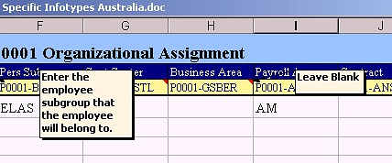

### Initial Data Load

The Initial data load sheet must be loaded before any other sheet. It holds infotype 0000, 0001, and 0002 information combined. The infotypes hold the following information:

## Actions - Infotype 0000 <Mandatory Infotype>

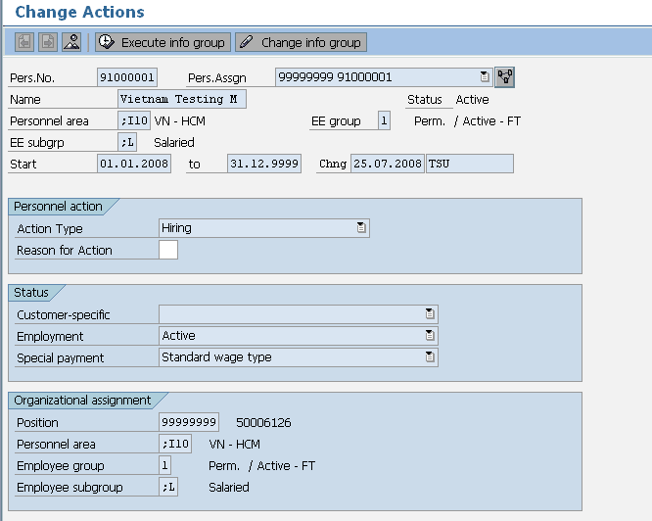

These are the mandatory fields

**Description**: All employees must hold an action infotype. It indicates if they are active or terminated and a new record is created when the action type (e.g. hire, transfer, termination) changes.

* Employment Status
* Personnel Area
* Employee group
* Employee subgroup information.

## Organisational Assignment - Infotype 0001 <Mandatory Infotype>

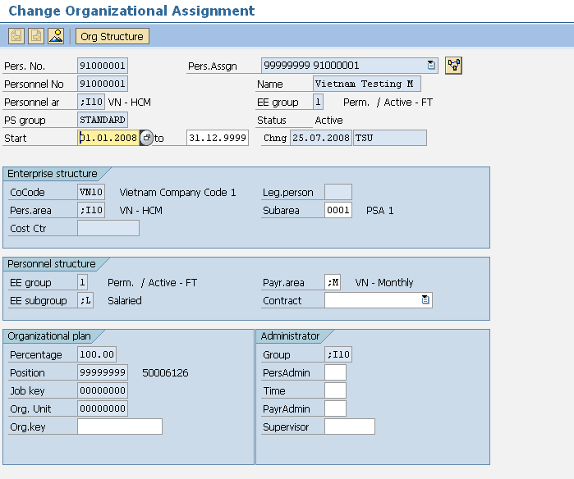

These are the mandatory fields for data load

**Description**: This holds all organisational information such as, company, location, department etc

* Personnel Area – Company Code
* Personnel Sub Area – Location
* Employee Group – Type of worker (e.g. Full-time Exempt)
* Employee Subgroup – Employment Band
* Cost centre
* Payroll Area
* Some clients may store additional info in this infotype

## Personal Data - Infotype 0002 <Mandatory Infotype>

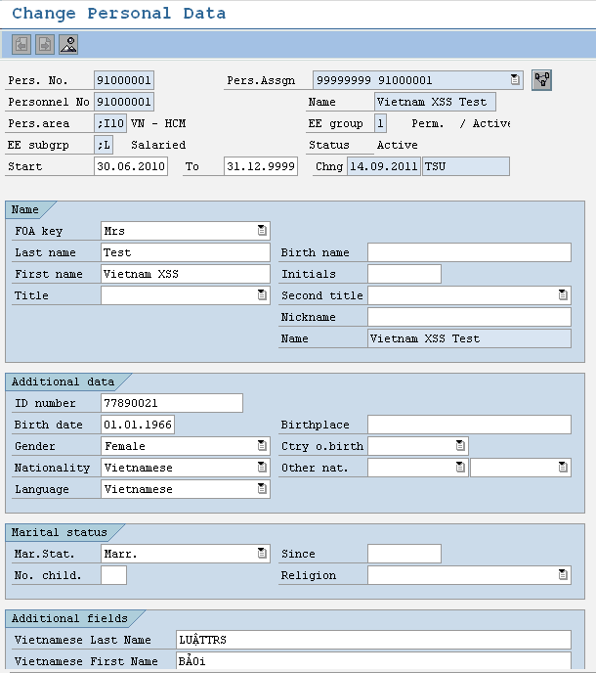

**Description**: This holds personal information relating to the employee.

* Form of Address
* Last Name
* First Name
* Gender
* Nationality
* Birth Date
* Marital Status
* Personal ID number
* Vietnamese Last Name
* Vietnamese First Name
* You also have the option of storing additional details if required

Note that IT0001 and IT0002 can be reloaded separately if necessary. Below are the relevant individual spreadsheets. These are not required to be completed for the initial load. They are for future changes.

## Addresses - Infotype 0006 <Mandatory Infotype>

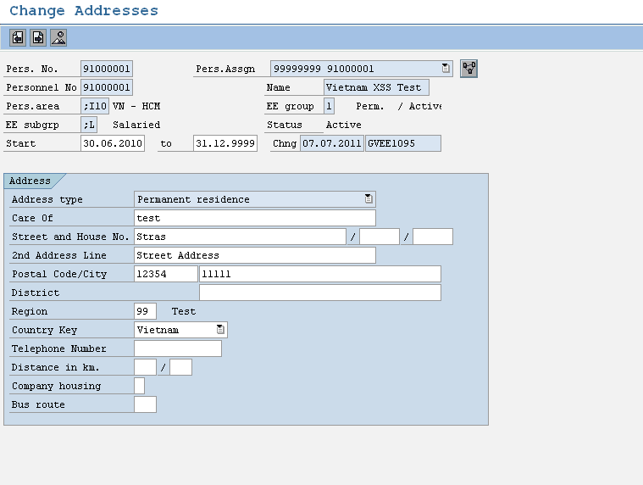

**Description**: Addresses Infotype 0006 subtype 0003 data load sheet stores details of employee’s address. Employees may have more than one address type (i.e. Permanent Residence and Postal address). Creating an additional address record for that employee in the data load sheet allows for this. The important fields are:

**Addresses – Infotype 0006:**

* Address Type (Each employee must have Address Type 3 – other subtypes are optional)
* House Number/Street
* Postal Code – Four Digits
* City/District
* State
* Country

## Planned Working Time - Infotype 0007 <Mandatory Infotype>

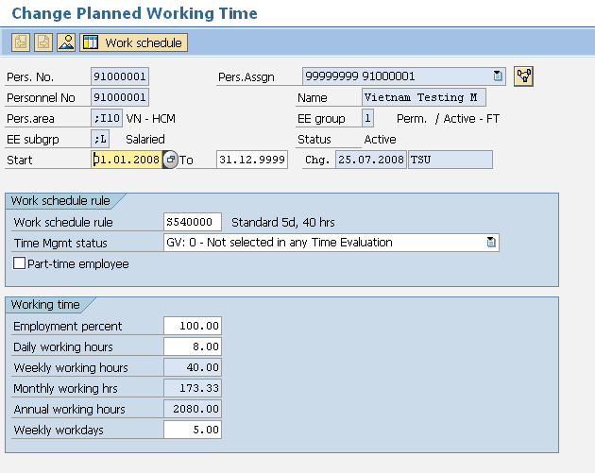

This is the only field you need to maintain. The other fields are populated from the work schedule rule

**Description:** Infotype 0007 holds employee work schedule information. The work schedule rule defines the hours worked. There will be a different rule for each country. There may be many more than one work schedule rule available in each country.

**Infotype 0007 loads the following information:**

* Work Schedule Rule
* Employee Time Management
* Part-Time Employee status

NB. If you are interfacing IT0000, IT0001 and IT0002 then IT0007 will be automatically created. If there are multiple work schedule rules then you need to supply IT0007 since the interface can only create one work schedule per country.

## Basic Pay - Infotype 0008 <Mandatory Infotype>

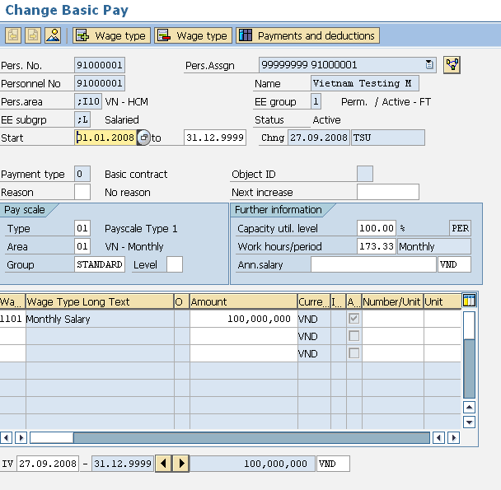

These are the mandatory fields. Note that the wagetypes for salary packages will vary depending on the client.

**Description**: This Infotype stores information about an employee’s salary and salary package. Additional Payments and Deductions are a separate Infotype. Infotype 0008 loads the following information:

**Basic Pay – Infotype 0008:**

* The Employee’s Annual Salary
* The Employee’s Monthly Salary
* Additional Salary Package wage types if applicable
* Hourly rates if applicable

## Bank Details - Infotype 0009 <Mandatory Infotype>

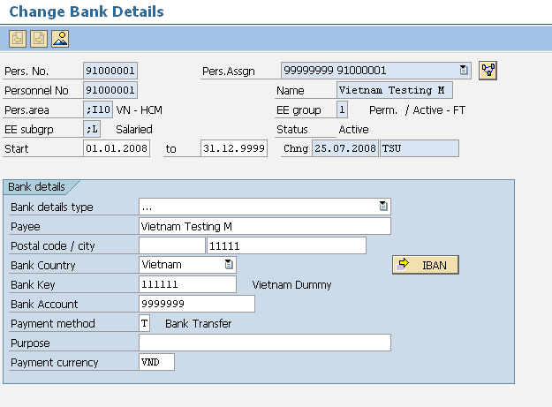

**Description**: This infotype holds details of the employee’s main bank account; an employee may have more than one bank details record. Additional banks hold the same details as the main bank but are entered through either an additional IT0009 record (in which case the money will come out of EVERY pay including off cycles) with a standard value or percentage or through an infotype 0011 record which works exactly like a deduction and will only come out of the main pay not an off cycle. Only employees with Payment method T will appear on the bank tape. Mandatory fields in Infotype 0009 are:

**Bank Details – Infotype 0009:**

* Bank Type (0 = Main Bank) (1 = Other Bank)
* Payee
* Postal Code
* City
* Bank Country
* Bank Key
* Account Number
* Payment Method
* Standard Value or Percentage (if “other” bank type)

## Permanent Allowances and Deductions/Temporary Allowances and Deductions Infotype 0014 and 0015

### IT0014

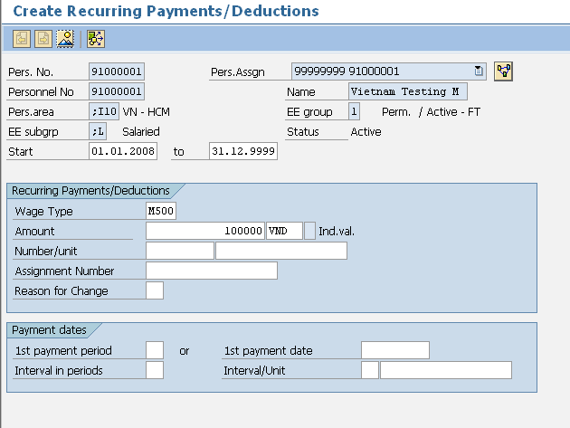

These are the mandatory fields. Note that you cannot enter both an amount and a number/unit. This will depend on how the wagetype is setup.

**Description**: Infotype 0014 stores the recurring allowances and deductions that are not included in the salary package; these wage types are permanent and paid monthly. Important Fields are:

**Permanent Allowances/Deductions - Infotype 0014:**

* Wage Type
* Amount
* Number/Unit
* Currency
* Start and End Dates (end date must be 31.12.9999)

### IT0015

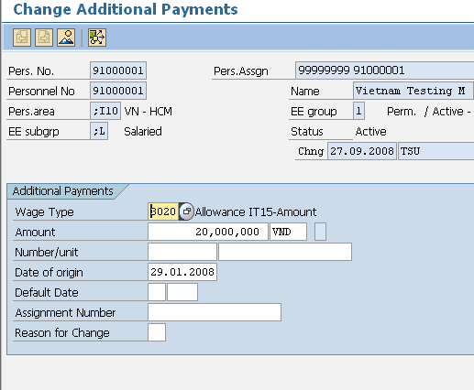

These are the mandatory fields. Note that you cannot enter both an amount and a number/unit. This will depend on how the wagetype is setup.

**Description:** Infotype 0015 is used for one off payments; these are known as ad-hoc payments. Important Fields are:

**Additional Payments – Infotype 0015:**

* Wage Type
* Amount
* Number/Unit
* Currency
* Date of Origin (Start and End Dates in the spreadsheet must be the same)

## Family Member / Dependents - Infotype 0021

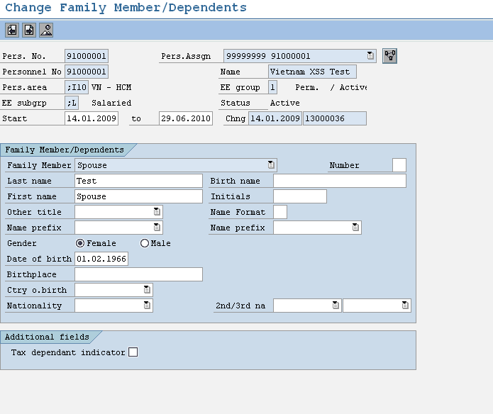

**Description:** Infotype 0021 is used for family member or dependents details

**Family Member / Dependents – Infotype 0021:**

* Family Member Type
* First Name
* Last name
* Gender
* Date of birth
* Birthplace
* Tax dependant indicator (to indicate the member is tax dependant or not and create link to IT9522)

## Change Additional Personal Data - Infotype 0077

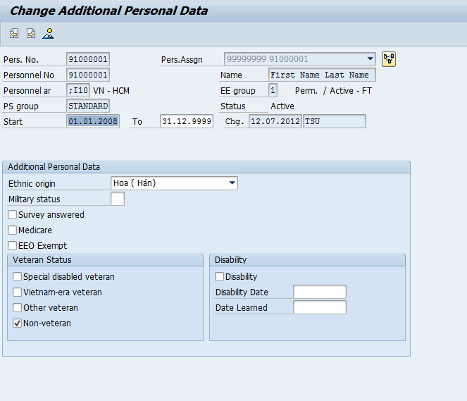

**Description:** Infotype 0077 is used for record Ethnic origin

**Change Additional Personal Data – Infotype 0077:**

* Ethnic Origin (use in A01a-TS report)

## Personal ID - Infotype 0105 <Mandatory Infotype>

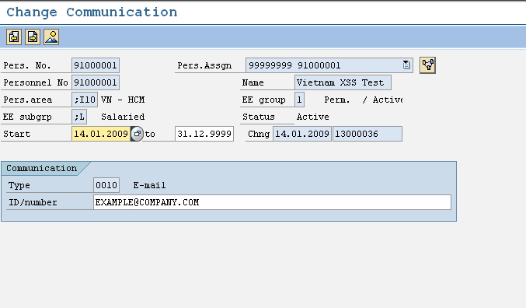

**Description:** Infotype 0105 is used to store employee email address

**Communication – Infotype 0105:**

* Type 0010
* ID number for email address

## Personal ID - Infotype 0185 <Mandatory Infotype>

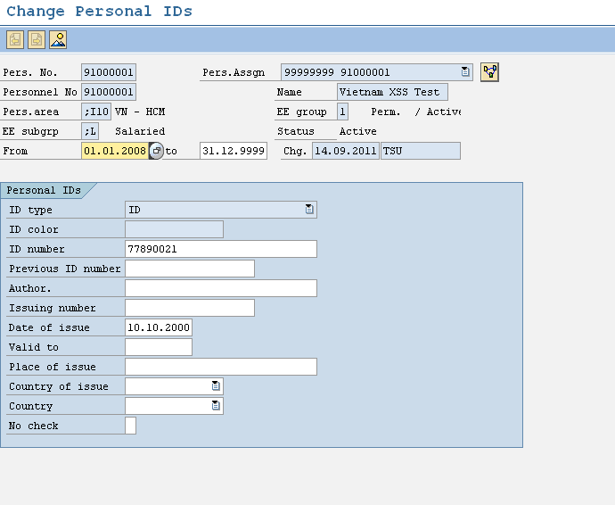

**Description:** Infotype 0185 is used to store employee Personal ID issue date

**Personal ID – Infotype 0185:**

* ID number (default from IT0002)
* Date of issue
* Place of issue

## Absence Quotas - Infotype 2006

All you need to supply when loading absence quotas is the quota type, start and end date. The balances are loaded later.

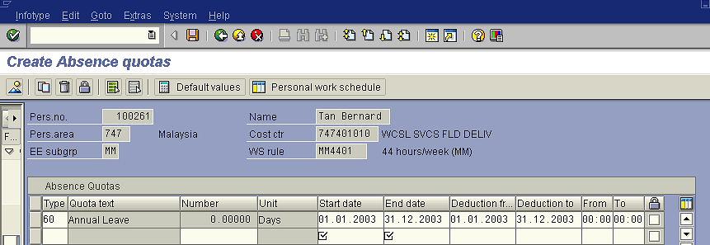

**Description:** In SAP leave is recorded as an absence. Some absences are linked to leave quotas that hold the entitlement and pro-rata values. These leave types are annual leave, sick leave and long service leave etc. When employees are hired a record is created for annual leave, sick leave and long service leave but no quotas are loaded at this point, they are left blank. Infotype 2006 loads the following information:

**Absence Quotas – Infotype 2006:**

* Start and End/To Dates
* Leave Type (e.g. Annual = 60, Sick = 70, subtypes may vary depending on the client)

## Quota Corrections - Infotype 2013

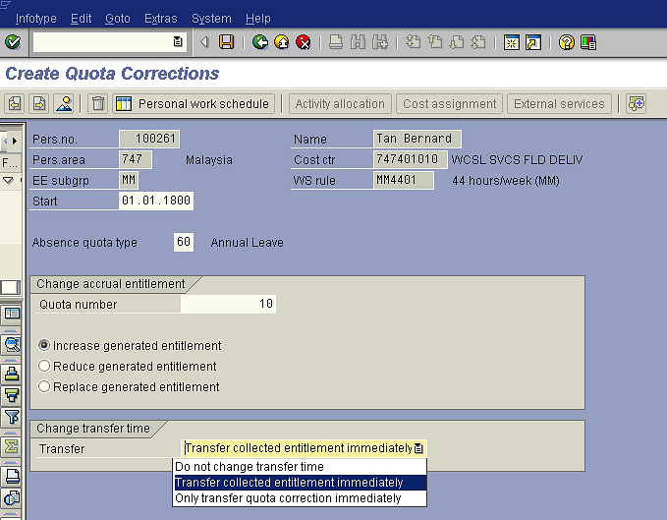

An entry must be made in all these fields. The most common options are shown. If you wish the entitlement only to be transferred on anniversary you would select “Do not change transfer time”

**Description:** Infotype 2013 allows you to increase, reduce or replace leave balances for the appropriate leave type. Therefore when you have loaded an IT2006 for each employee for each leave type that they are entitled to you can use this infotype to load the existing balances into IT2006. Quota Corrections (IT2013) loads the following fields:

**Quota Corrections – Infotype 2013:**

* From and To Dates must be the same
* Quota Type
* Quota Number
* Increasing, Reducing, or Replacing Leave Balance
* Transfer Time

## Absences - Infotype 2001

Infotype 2001 is NOT required for the initial data load!

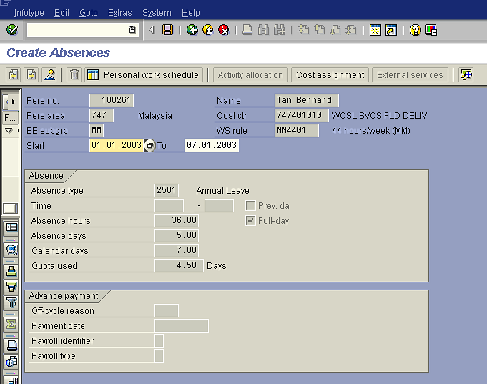

These items are actually entered in the front screen when entered manually. The calendar days default from the start and end dates entered. When loading by spreadsheet you should also only enter the start and end dates. Again the days will default.

**Description:** This data load sheet loads employee leave entries. However in reality you will rarely need to load leave entries. It is either done by the payroll team or through ESS on an ad hoc basis.

Infotype 2001 holds the following information:

**Leave – Infotype 2001:**

* Start and end Dates
* Wage Type
* Start and End Times/Absence Hours (only enter if less than one day’s leave is being applied for)

## Employee Remuneration Information - Infotype 2010

Infotype 2001 is NOT required for the initial data load!

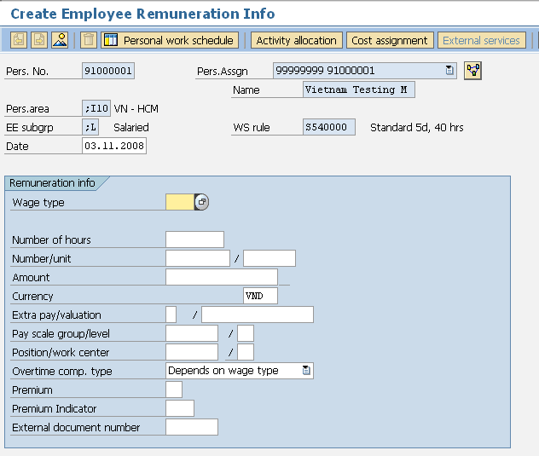

These fields are rarely used but can be utilized if necessary

These are the mandatory fields. Note that you will either use hours, number unit or amount, not a combination. This will depend on the wagetype and how it works

Alternative cost centres can be entered here

**Description:** This is used to input time sheet entries such as overtime and meal allowances. However this is sometimes done via ESS or manually by the payroll team. Important fields’ infotype 2010 loads are:

**Employee Remuneration Information – Infotype 2010:**

* Start and end Dates
* Wage Type
* Amount/Hours
* Note that in the spreadsheet there is a field for Cost centre so that a payment can be assigned to a different cost centre. To do this manually you would click on the cost assignment button.

# Country Specific Infotypes

## Change Personal Income Tax - Infotype 9520 <Mandatory Infotype>

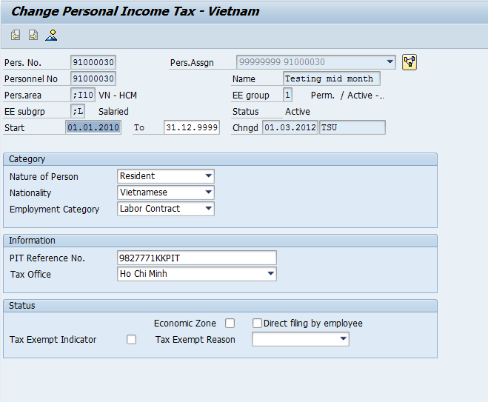

**Description:** This is used to store the employee’s tax declaration details. Key fields in infotype 9520 are:

* Nature of Person (Resident/Non-resident)
* Nationality
* Employment Category
* Employee PIT Reference Number
* Tax Office location
* Economic Zone
* Direct filling by employee (fill in tax finalization month period)
* Tax Exempt Indicator
* Tax Exempt Reason

## Change Social Insurance Vietnam - Infotype 9521 <Mandatory Infotype>

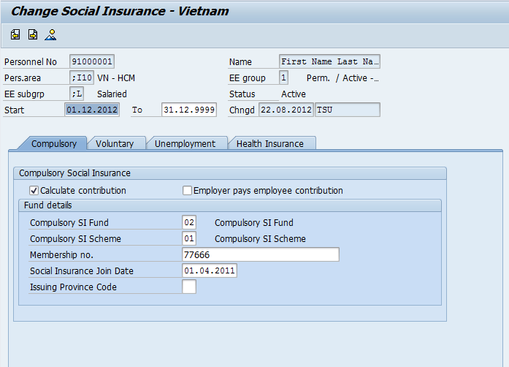

**Description:** This is used to store Employee’s Social Insurance details and applicable insurance types. Key fields in infotype 9521 are:

### Compulsory Insurance

* Calculate contribution
* Employer pays employee contribution
* Compulsory SI Fund
* Compulsory SI Scheme
* Membership no
* Social Insurance Join Date (use validate the SI new participate)
* Issuing Province Code (use in A01a-TS report)

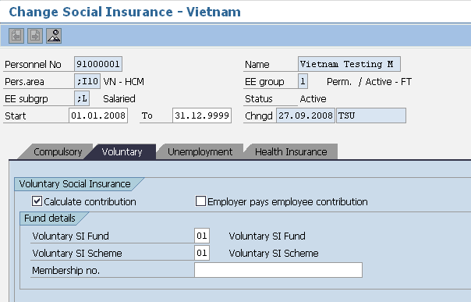

### Voluntary Insurance

* Calculate contribution
* Employer pays employee contribution
* Voluntary SI Fund
* Voluntary SI Scheme
* Membership no

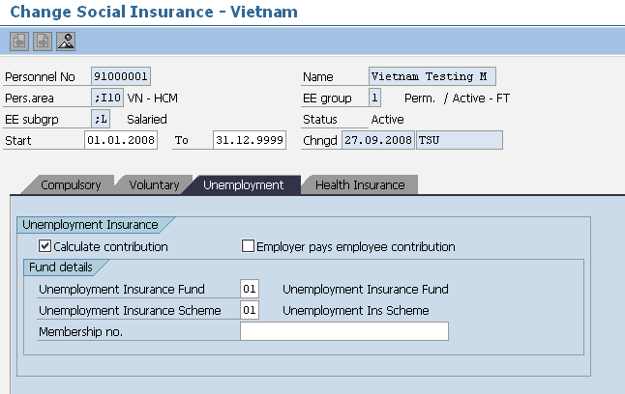

### Unemployment Insurance

* Calculate contribution
* Employer pays employee contribution
* Unemployment Insurance Fund
* Unemployment Insurance Scheme
* Membership no

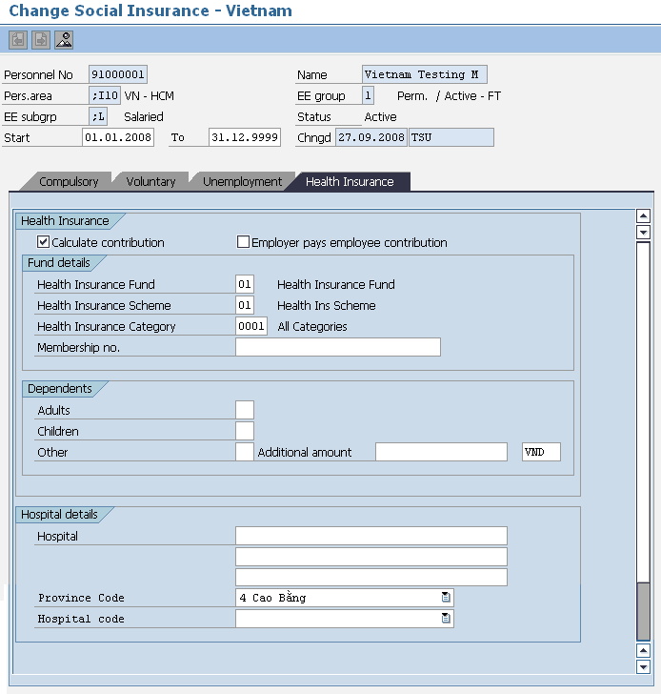

### Health Insurance

* Health Insurance Fund contribution
* Health Insurance Scheme
* Health Insurance Category
* Membership no
* Dependents
* Hospital Details
* Province Code (use on SI report)
* Hospital Code (use on SI report)

## Vietnam SI history - Infotype 9523 <Mandatory Infotype>

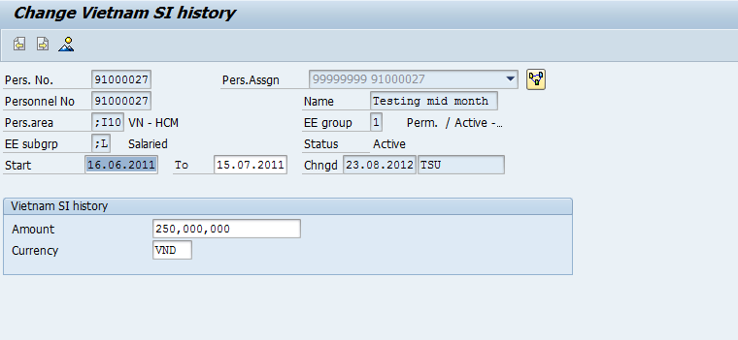

**Description:** This is used to record SI contract salary amount submit to the government

**Vietnam SI history – Infotype 9523:**

* Amount
* Currency

## Annual Values for Tax and Reporting - Infotype 9524

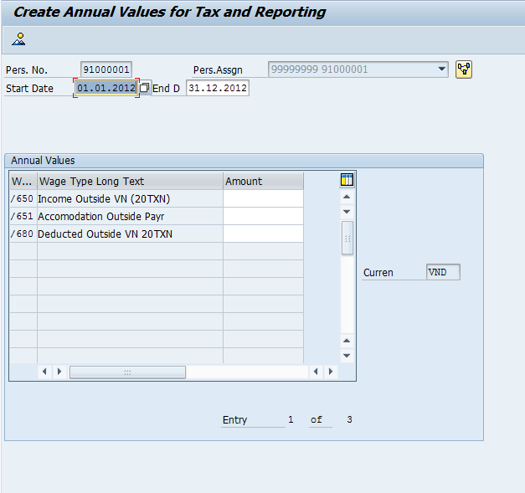

**Description:** This is used to input data print on form 20TXN under section 4, 5 and 6

**Annual values for Tax Reporting – Infotype 9524:**

* /650 Income Outside VN (20TXN)
* /651 Accommodation Outside Payroll
* /Deducted Outside VN 20TXN

## Vietnam Working Conditions - Infotype 9525

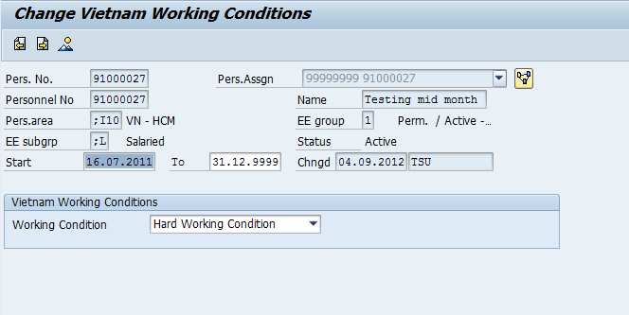

**Description:** This is used to input data print on form A01a-TS under section III

**Annual values for Tax Reporting – Infotype 9525:**

* Working Condition